|  |  |  |  |  |
| --- | --- | --- | --- | --- |
|  |  |  | Project Milestone 1 | |
|  |  |  |  |  |
|  |  |  | Project Name: | Biochemical Plate, Assay, and Result Management system |
|  |  |  |
|  | Team: | West-East99 (We99) |
|  | Date: | 23rd Feb 2015 |
| CSCIE-99  Project | Customer: | Peter Henstock |
|  |  |  |  |
|  |  |
|  |  |  | |
|  |  |  |  | |

Contents

1. Document Administration 3

1.1 Document Change History 3

1.2 Document Content Owners 3

1.3 Document Reviewers 4

1.4 Document Approvers 4

2. Assumptions and Constraints 5

2.1 Assumptions 5

2.2 Constraints 5

3. Scope 6

3.1 In Scope 6

3.2 Out of Scope 6

4. Proposed Functionality 7

4.1 Overview 7

5. Business (Functional) Requirements 8

5.1 Security Functional Requirements 8

5.1.1 Security Overview 8

5.1.2 Sample Screens / StoryBoard 8

5.1.3 Open Issues / Questions Security Section 10

5.2 Plate Management Requirements 11

5.2.1 Plate Management Overview 11

5.2.2 Sample Screens / Story Board 12

5.2.3 Open Issues / Questions Plate Management 13

5.3 Experiment Management Requirements 14

5.3.1 Overview 14

5.3.2 Sample Screens / Story Board 15

5.3.3 Open Issues / Questions Experiment Management 16

5.4 Results Analysis Requirements 17

5.4.1 Overview 17

5.4.2 Sample Screens / Story Boards 17

5.4.3 Open Issues / Questions Results Analysis 17

5.5 Special Feature Proposals 18

5.5.1 Overview 18

5.5.2 Interactive Visualization 18

5.5.3 Audit Trail 20

5.5.4 Four Eyes Protocol 21

5.5.5 Flexible Plate Template Editor 22

5.5.6 Plate Sharing 22

5.5.7 Support Machine / Equipment File parsers 22

5.5.8 Open Issues / Questions Special Features 22



# Document Administration

## Document Change History

| Date | Author | Version | Description of Change |
| --- | --- | --- | --- |
| 23rd February 2015 | Alan Orcharton | 1.0 | Initial Document |
| 24th February 2015 | Sean Sinnott | 1.1 | Added information to section 5.4 (results import) – and some questions related to the selection of points for linear regressions. |
| 25th February 2015 | AlanOrcharton | 1.2 | Merge comments from Mark and Alex |
| 1st March 2015 | Alex Zaman | 2.2 | Updated Plate Editor Text and mockups. |

## Document Content Owners

| Role | Name |
| --- | --- |
| Author | Alan Orcharton |
| Contributor | Alexander Zaman |
| Contributor | Tim Stefanski |
| Contributor | Mark Ford |
| Contributor | Sean Sinnott |

## Document Reviewers

| Name | Role |
| --- | --- |
| Peter Henstock | Customer |
| Robert Zupko | Consultant |
| Alexander Zaman | We99 Front End Developer |
| Tim Stefanski | We99 Front End Developer |
| Sean Sinnott | We99 Front End Developer |
| Mark Ford | We99 Back End Developer |
| Alan Orcharton | We99 Back End Developer |

## Document Approvers

| Name | Role | Signature / Electronic approval | Sign-off Date |
| --- | --- | --- | --- |
| Peter Henstock | Customer |  |  |
|  |  |  |  |
|  |  |  |  |

## Project Vision

## Introduction

The purpose of this document is to assist the We99 project team and the customer gain a common understanding of the high level functionality of the Biomedical Plate, Assay and Result Management system. The requirements have been documented in storyboard format. A short description of the functionality is included with some mockup screen shots. This format is intended to provide a good overview of the system from a users point of view.

# Project Overview

## Project Vision

Our overall vision is to create a responsive web application that can assist scientists with managing the data associated with their experiments. We have decided to develop our project as a Java web application with REST web services. A web application will easily allow multiple users to access our program from whatever internet-capable device they have available, such a workstation or a mobile device. The Front end will be a Angular single page application to provide a desktop like response.

A low maintenance web based Biochemical plate and assay management system with specialized visual tools to enable scientists to quickly QC and analyze experiment results. We propose including some beautiful visual tools to assist the scientist in the analysis experiment results.

## Current Process Problem being solved

# Assumptions and Constraints

## Assumptions

## Constraints

* Software Solution must be free. All source code for the solution is to be made available to the open source community. Any part of the system may be openly used or further developed.

# Scope

## In Scope

## Out of Scope

# Proposed Functionality

## Overview

We propose a web-based software solution to facilitate the creation of Biochemical plate specifications, the management of experiments (assays), and the analysis of results.

We have broken the requirements into sections to facilitate the review and analysis of the functional requirements as follows:

**Security**

Requirements associated with logging into the system and defining user roles within the system.

**Plate Management**

The definition, creation, and storage of biochemical plates and plate sets to be used in experiments

**Experiment Management**

The definition, creation, and storage of experiments conducted.

**Results Analysis**

Functionality associated with loading, analyzing, reviewing, and storing experiment results.

**Special Features**

Proposals for advanced features to enhance the product

# Business (Functional) Requirements

## Security Functional Requirements

### Security Overview

We propose that all users of the system must have

* An email address – for use as a unique identifier and during the login process.
* An account – to logon to the system
* A User role – Administrator or Scientist

Nearly all of the operations in the system require a specific permission granted to the user in order to access the feature. These permissions are grouped into Roles and a User is assigned a single Role. This approach allows for easy expansion of the system to include user defined roles or customization of the existing roles.

A user with the Administrator role has access to create and remove user accounts.

We also propose the ability to create “Teams” for an experiment. A team lead with and administrator role would have the ability to create a team of scientists. See Experiment Management section.

We propose requiring the following information for a user account:

* **Email address** – used at the username. Email addresses help ensure unique usernames. The email address may by used in future for sending notification to the user.
* **First name / Last name** – used to identify the user in a more friendly form.
* **Password** – a user supplied password for authentication.

Users with an Administrator role have access to create and remove user accounts and to reset user passwords.

Administrative users also have the ability to add data on test equipment used in experiments. This information can be used to help identify defective equipment and functionality can be expanded to incorporate file parsers to assist the user in loading results produced from a machine that may be in a non-standard format (see special features).

### Sample Screens / Story Board

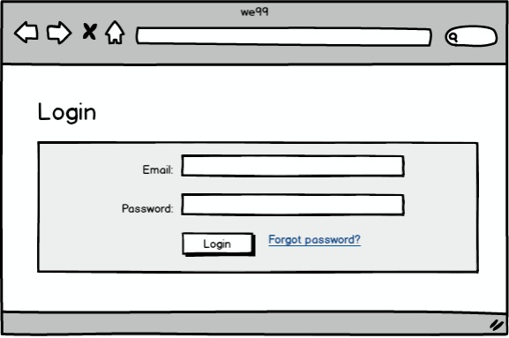

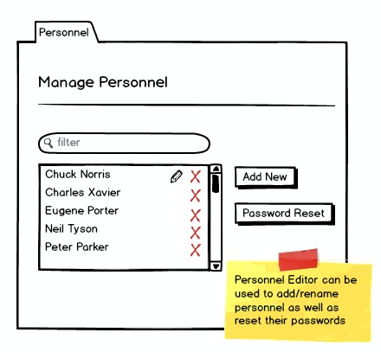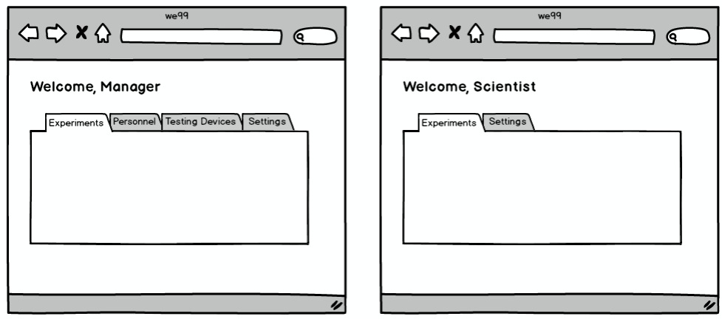

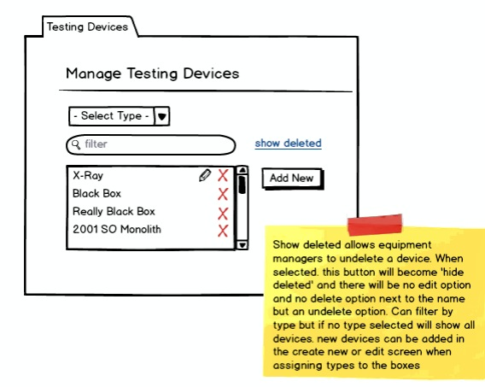

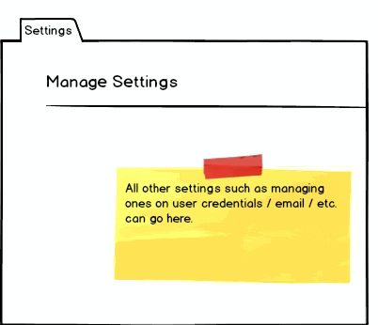

### Open Issues / Questions Security Section

| # | Description | NOtes |
| --- | --- | --- |
| 1 | Can we use Testing devices to manage import export formats of files associated with the device |  |
| 2 | Roles – Are there any other roles besides Manager/Administrator and Scientist that we should add |  |
| 3 | Organization Units – Is there a need to allow organizational groupings to manage accounts in large corporate environments |  |

## 

## Plate Management Requirements

### Plate Management Overview

Plate Management covers creating specification of the contents of microtitre plates to be used in experiments. Users can create plates of any dimension and can specify the compound and the concentration of each compound to be added to each well.

The plate management service offers a central place for the user to manage and create plate sets for their experiment. The initial screen offers an overview of existing sets and their status. It also offers quick access to create new plates and advance their plates to the next stage.

**Plate Details**

Plates are identified with a plateId (a.k.a barcode). Plates are assumed to be rectangular and can be created in any rectangular dimension. The dimension is specified using the number of rows and the number of columns. The product of rows x columns defines the number of wells that a plate possesses. wells themselves are identified by the plate to which they belong and their row and column coordinates.

Plates are made ready for experiment by filling its wells with a specific concentration of a compound.

Compounds on plates are identified by an experiment specific code and classification. Compounds are classified with user defined classifications representing their role in the experiment for example:

* EXP – experimental compound
* POS – positive control
* NEG – negative control

The concentration of a compound is specified via a number and a unit of measure (e.g., 20 uM).

**Creating New Plate Sets**

New plates can be created using the ‘Add New’ button. This leads to a plate set creation wizard. The user uses this wizard to provide relevant information such as:

* the name of the plate
* plate type (make / model)
* # of plates and their IDs
* Dosages per plate

Along with information entered in the forms, the wizard also asks the user to provide the following information by uploading a csv file representing values in a reference table or plate map:

* Compound – Symbol mapping table
* Symbol – well mapping of plates
* Dosage – well mappings of plates

The specific layout of the wizard can be seen in the mockups part of this section.

**Plate Import / Export**

Plate set setup information can be save and reused using the import and export feature. Imports and exports are stored in cleartext json format. This allows clients to export the data into their own processing systems or even edit the plates manually if the changes are very minor.

The export feature just requires a plate set to be selected and will save the file.

The Import feature receives a json export and asks the user to reassign some of the unique fields (plate set name and plate Ids). It will populate the database based on the associated json.

**Updating Plate Set Status**

Plate Sets can be updated from the main plate manager screen using the links next to the plate in the ‘Action’ column.

When a plate created, it reaches a preparing state. ‘Mark prepared’ will mark the plate as prepared and assign the marker as the preparer [ASSUMPTION: marker == preparer]

When the plate is prepared, the ‘send to device’ button will be available. Upon clicking it the state will change to ‘in testing’ and the marker will be identified as the tester. [ASSUMPTION: marker == tester]

When the plate is ‘in testing’ the upload analysis will become available. this link raises a popup allowing the user to upload the analysis provided by the machine. [DETAILS NOT FLUSHED OUT. is the analysis parsed, what other information is needed along with the file?] . Upon upload, the state will change to ‘tested’. [ASSUMPTION: tester == uploader]

In the tested state, users will be able to reach the analysis interface using the ‘view analysis’ link.

### Sample Screens / Story Board

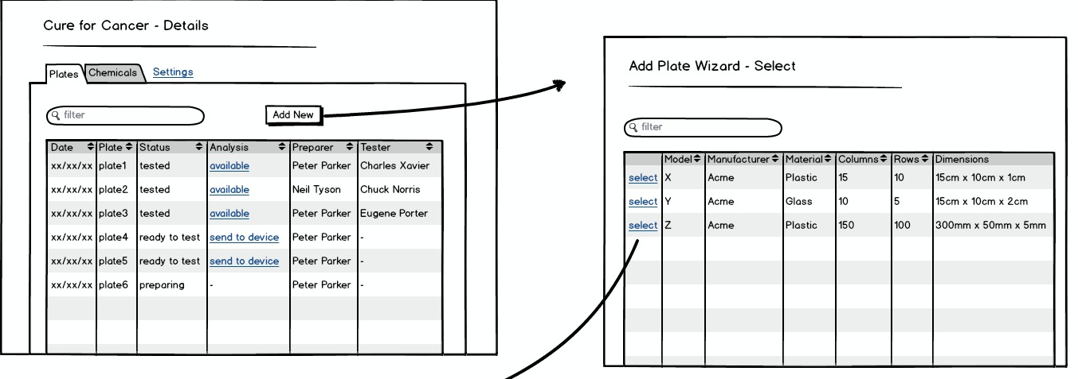

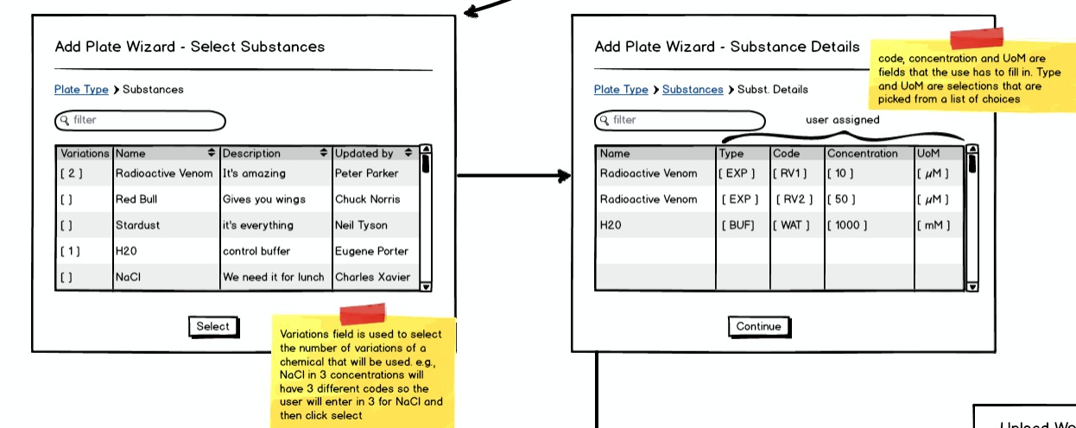

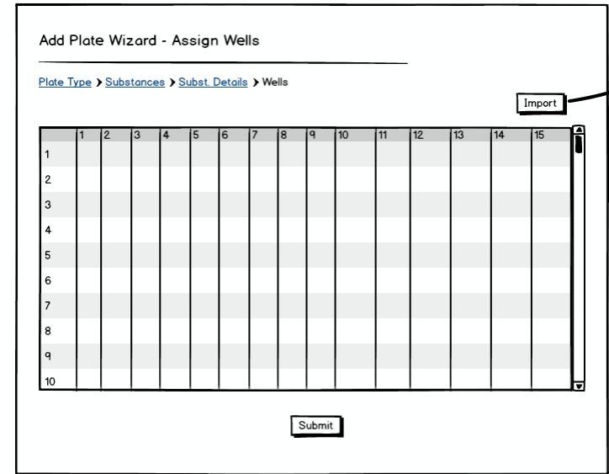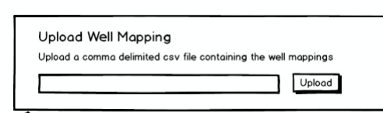

PROPOSAL: Shared plate button.

A shared plate could be produced here.

- click the shared plate button

- Goes to page asking for which experiments to share with

- Goes to the select plate page

- Goes to page asking to select rows and columns. Shows the mapping and allow users to select rows and columns that they want. Ideally the user could highlight a cell and click and drag to get the range they want. However, if we can’t do that then just select the rows and columns with checkboxes, their intersect is what is selected.

- The user is taken to the select substance page and the rest of the wizard is the same as the regular plate creation wizard.

For now, imports and exports of shared plates are not supported.

Shared Plate Edit:

Editing plates is currently not supported.

Shared Plate Deletion:

If the delete button is selected, a shared plate is only removed from the list of available plates and only visibility to the experiment is removed. The plate is only truly deleted when all experiments remove access

### Open Issues / Questions Plate Management

| # | Description | NOtes |
| --- | --- | --- |
| 1 | Is there a need for Plate Templates? Adding placeholders for compounds, controls and empty. Perhaps including an index for dosage. Merge the Compound list with the template to create a plate.  Is cloning the plate a reasonable alternative to the template concept | Plate templates and cloning can coexist. When creating an initial plate, plate templates are the list of available plate structures. There are only a few of them that are sourced from manufacturers. Plates are created from the templates by deciding what substance goes where. Cloning will clone plates not templates and give the option of editing the mappings. This will allow scientist to make new plates more quickly but would not replace the need for plate templates |
| 2 | For dose response analysis. Applying doses or concentrations of compounds. Is there a shorthand e.g. 20uM 5-fold? |  |
| 3 | Ability to create plates of any dimension. does not account for non-rectangular (e.g., round) plates or 3d plates. | Robert confirmed, this is NOT required |
| 4 | Exporting plate specs. Is there a standard format? Do we need to handle with different parsers tied to equipment type? |  |
| 5 | Picture 1 will also list shared plates. A new status of ‘not started’ will exist. when clicked, user will be taken to a page where they can select their plate region. Then they are taken to substance selection page and continue the rest of the wizard the same way | For shared plates the plate setup page will not show the entire mapping, instead it will show the part of the mapping that is available to the user and the rest will be grey boxes |
| 6 | We should consider having add plate set wizard to produce a json document server side. then the import wizard and the add new plate wizard would both use the same call to populate the database |  |

## Experiment Management Requirements

### Overview

Experiments can be created and deleted by an administrative user. An experiment is identified with a unique name. A description of the experiment can also be included. An administrative user can also create teams of scientists for an experiment.

Experiments may use a single of a set of filled plates. The plates used in an experiment can be listed. A team member can add new plates to an experiment.

Plates have a status:

* **Creating**– a plate in this state is in the process of being defined (see plate management)
  + Shared plates that have not been allocated can be started by clicked not started. Note that all shared plates have a common ‘Ready to Test’ and Tested state.
* **Ready to test** – a plate in this state is filled and is ready to be tested.
* **Tested** – a plate in this state has been tested and results are pending.

**Plates also have an Analysis status:**

* **Available** – Test results are available. When the available link is pressed the user is directed to the results analysis for that plate.
* **Send to Device** – Plates can be assigned to a specific device for testing. When the send to device link is pressed the user may select the test equipment that the plate is to be send to.
* **In testing** – When a plate is sent to a device for testing its status changes to in testing.
* **n/a** – the plate can also have no analysis state.

### Sample Screens / Story Board

**Plate Management Screen and Import / Export Popups**

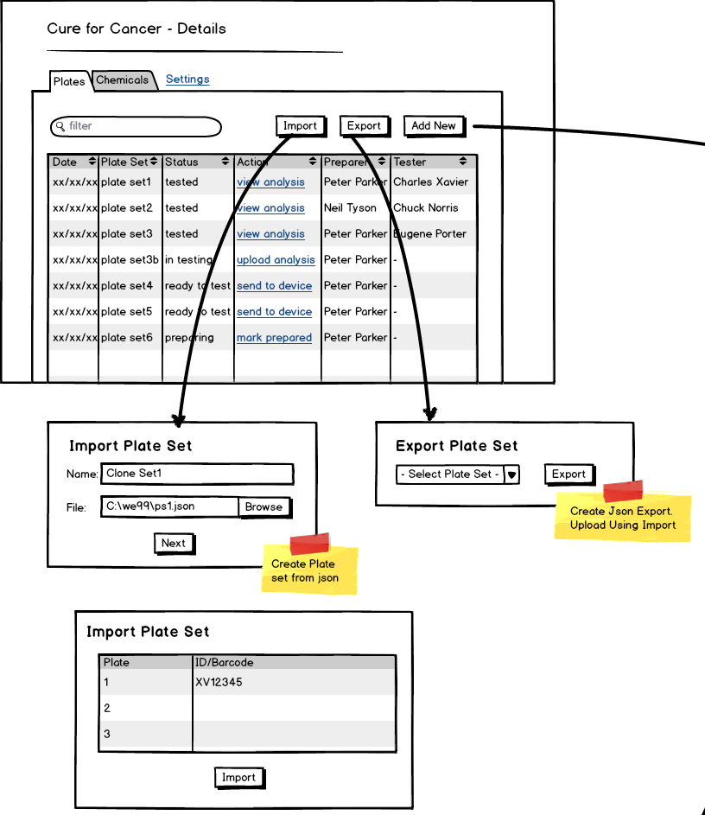

**Add New plate wizard**

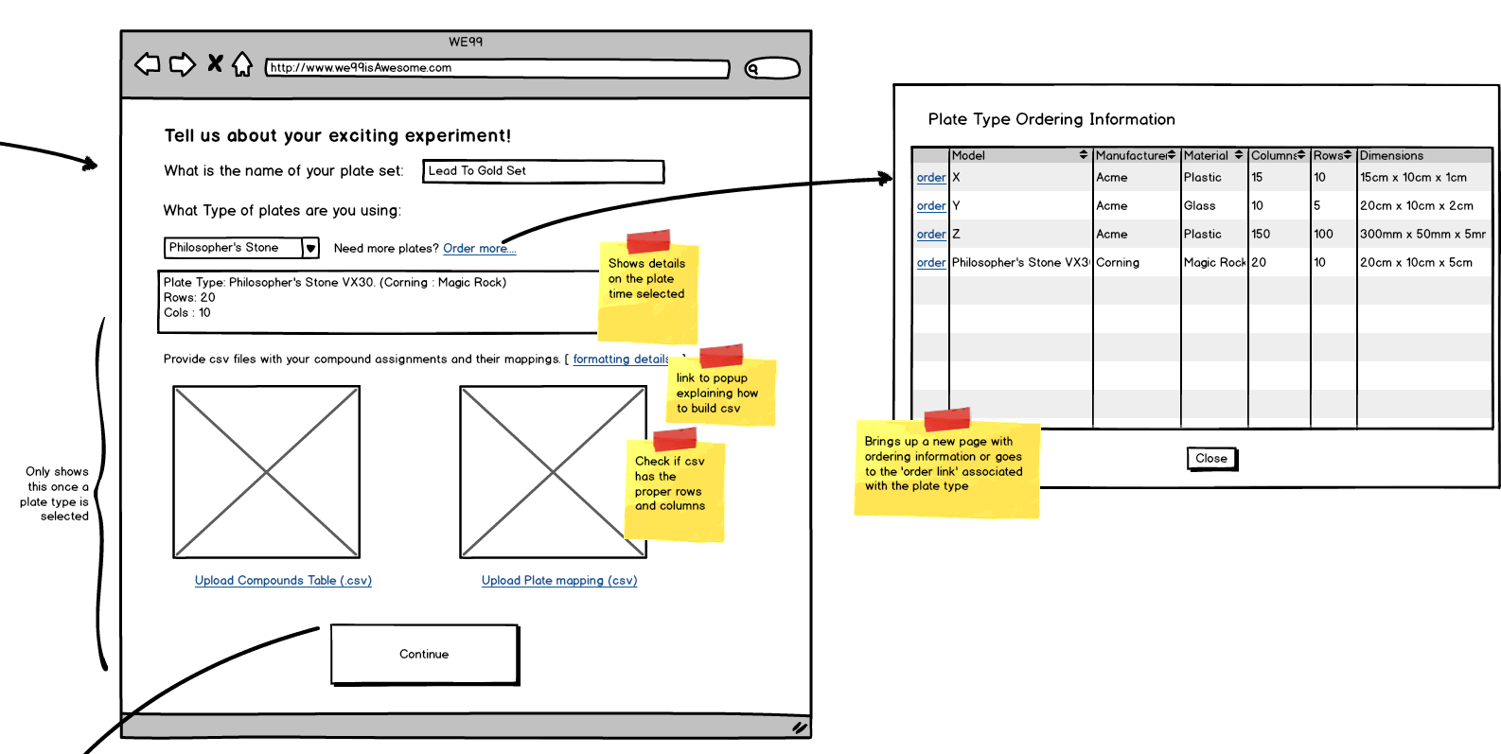

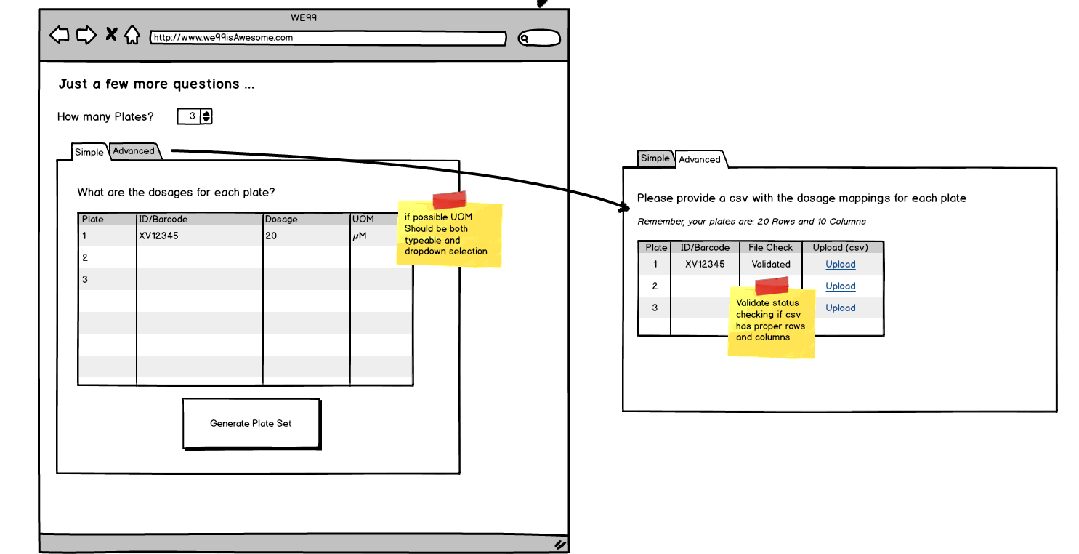

### Open Issues / Questions Experiment Management

| # | Description | NOtes |
| --- | --- | --- |
| 1 | Adding Compounds. Is there a need to do this in a bulk import? |  |
| 2 | note adding a team member removes them from the list of available team members |  |
| 3 | Might need Need a separate role and management view for ‘mark as prepared’. | e.g., this is where a lab assistant could mark plates as prepared and the status is updated to the project. |

## Results Analysis Requirements

### Overview

A plate will be analyzed by a machine - which will generate a structured text file as output. The user will upload the structured text file into the web application and select an appropriate parser to convert it into a result set. The results for the uploaded plates will be displayed to the user for validation in the form of a heat map.

While reviewing the results as a heat map the user will be able to read information about,

1. The results values.
2. The concentration of compounds in the wells.
3. The compounds in the wells.
4. What type of well’s are which (ex. EXP, POS, NEG).

### Sample Screens / Story Boards

Step 1 – Select a file and an algorithm to upload.

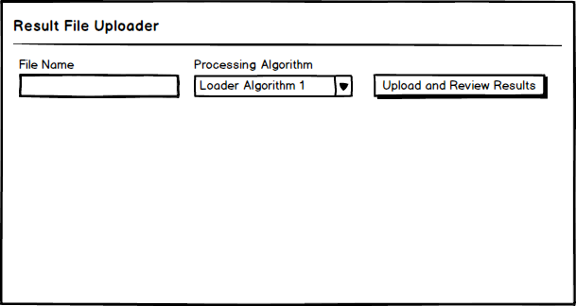

Step 2 – Review the results and save them if they look appropriate.

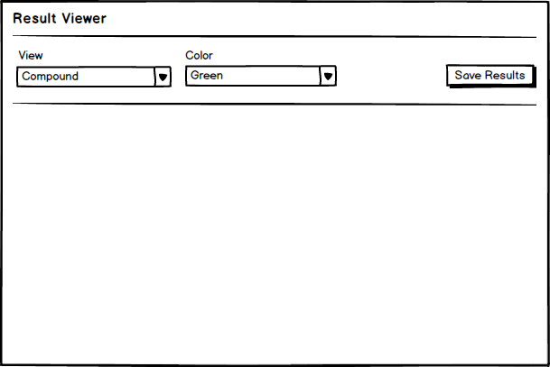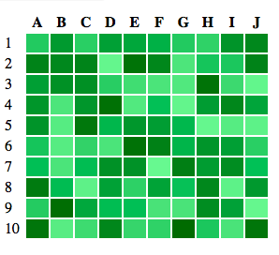

Plate 1

Plate 2

Plate 3

### Open Issues / Questions Results Analysis

| # | Description | NOtes |
| --- | --- | --- |
| 1 | When reviewing the result in the form of a heat map is there any workflow for processing the results beyond saving. For example -- if a plate looks like it has issues should the system allow them to flag the plate as problematic, etc? |  |
| 2 |  |  |
| 3 |  |  |

## Special Feature Proposals

### Overview

We have includes a few special features that we were considering implementing as part of the system.

### Interactive Visualization

Allow the user to remove plot points from an Experiment's results. They will see the raw data from the processing in a scatter plot where we fit a curve to the data. The user can select points in the UI and remove them which will cause the graph to render the curve line again.

We will track which points were removed and enable users to provide comments as to why they were removed.

When removing points, you can offer a preview view. This would generate a new regression on the fly when certain points are selected to be removed. This can either be saved which would create the change and audit trail or the scientist could cancel changes.

#### Sample Screens / Story Boards

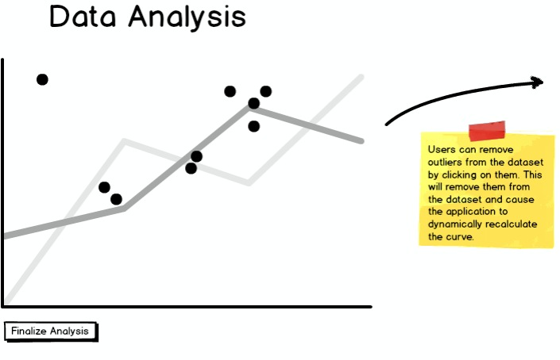

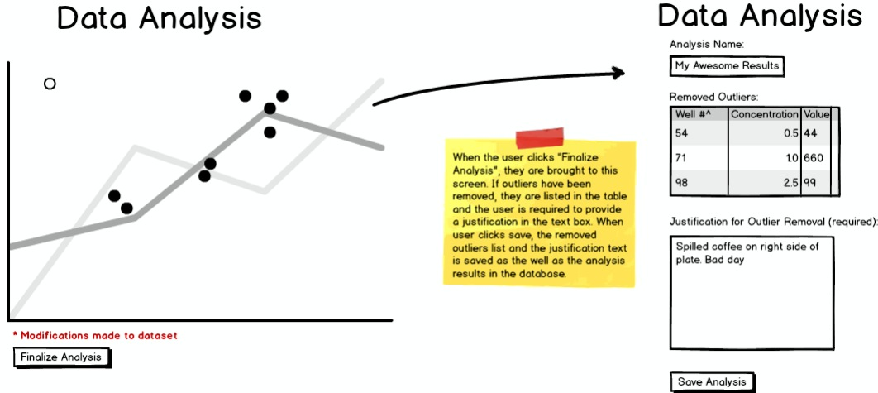

### Audit Trail

We could track whenever a Plate / Well / Dose / Experiment changes. This would allow users to know when something in the system has changed and may be necessary for internal reporting or perhaps regulatory agency requirements.

Assuming that we have some type of relational database, we should hook into the changes at the transaction level so the audit trail is captured in the same atomic operation as the data is changed. Note: there's a good library from Hibernate for this called Envers.

#### Sample Screens / Story Boards

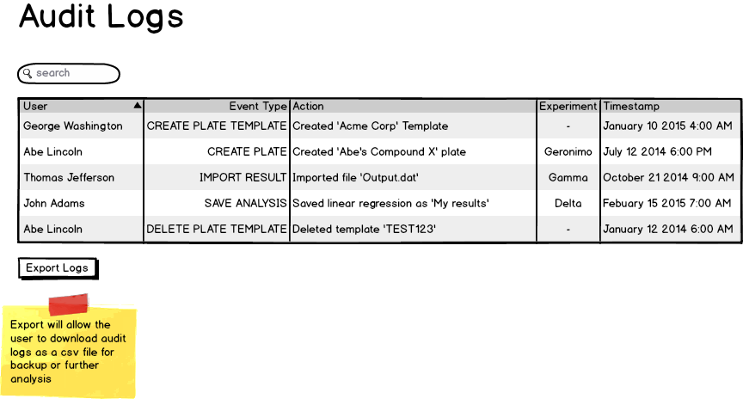

### Four Eyes Protocol

Changes to experiment results or perhaps the plate configuration before an experiment should require a second person to review or approve the change. This would assume that we have an authentication model in place so we know which users own an Experiment and thus which users would be eligible to approve the change,

#### Sample Screens / Story Boards

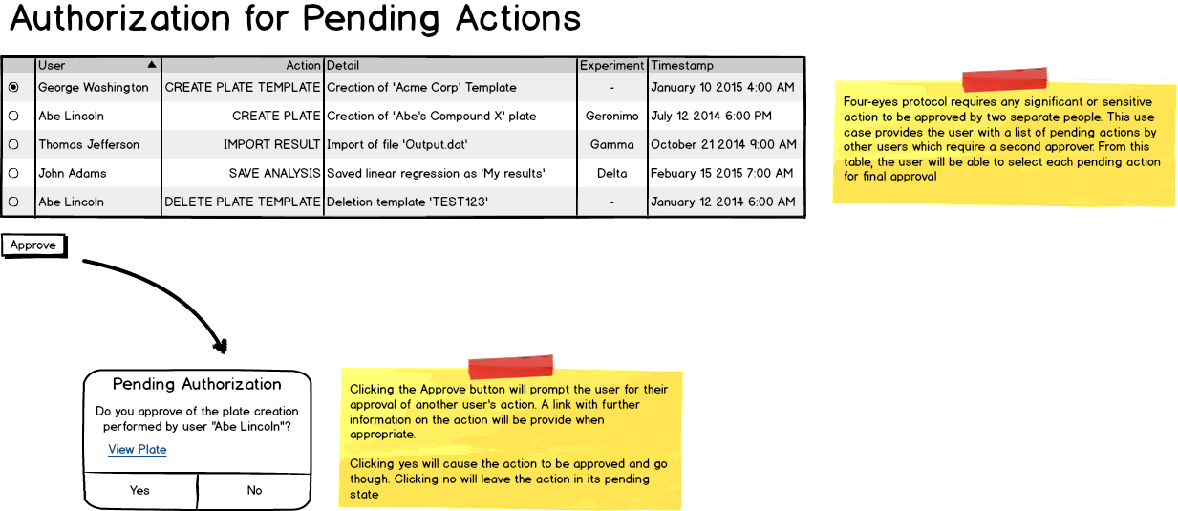

### Flexible Plate Template Editor

Plate templates can be saved and loaded so that they can be shared. The save file is a clear format (e.g., csv) that could be edited directly with a text editor/excel. Alternatively the webapp interface can have a table that lets you design the plate.

### Plate Sharing

In some cases a plate may need to be shared across multiple Experiments. This may be a cost or resource issue. In order to support this, we need to associate wells to an experiment and not assume that a plate belongs to a single Experiment.

### Support Machine / Equipment File parsers

If we are storing data regarding the equipment used for an experiment we could possibly have the ability to customize output file formats for the type of equipment. This could also apply to parsing the results files from different machine types.

### Open Issues / Questions Special Features

| # | Description | NOtes |
| --- | --- | --- |
| 1 | For the data analysis portion of this they are represented as scatter plots. What should the x and the y axis of the scatter plot be? |  |
| 2 | For the data analysis portion how should the result be filtered. Would people want to look at a specific compound across an entire experiment? Only look at a single plate at a time? Review all plates in an experiment? |  |
| 3 |  |  |

# High Level Design

## Architecture

## Web Services

# Project Planning and Estimating

## Iterations

### Overview

We99 has planned the project based on the Agile Methodology. The project is broken down into Iterations. The We99 team has planned 10 iterations, each iteration being 1 week in duration. The iteration starts on the Thursday of each week and closes on the following Wednesday. Every iteration the project team will be delivering several units of functionality defined by stories.

### Iteration Calendar

The table below specifies the iteration calendar for the We99 Team

|  |  |  |  |
| --- | --- | --- | --- |
| **Iteration Number** | **Open Date** | **Close Date** | **Notes** |
| 1 | March 5th 2015 | March 11th 2015 | Milestone1  Presentation March 5th |
| 2 | March 12th 2015 | March 18th 2015 |  |
| 3 | March 19th 2015 | March 25th 2015 | Spring Break March 15th-22nd |
| 4 | March 26th 2015 | April 1st 2015 |  |
| 5 | April 2nd 2015 | April 8th 2015 | Milestone 2  Presentation April 9th |
| 6 | April 9th 2015 | April 15th 2015 |  |
| 7 | April 16th 2015 | April 22nd 2015 |  |
| 8 | April 23rd 2015 | April 29th 2015 |  |
| 9 | April 30th 2015 | May 6th 2015 | Milestone 3  Presentation May 7th |
| 10 | May 7th 2015 | May 13th 2015 | Final Report May 9  Presentation Faculty Committee May 14 |

## Stories and Estimates

## Main deliverables

# Project Risks

# Project Tools and Technical Stack